Q1. Create a new branch ‘css-assignments’.

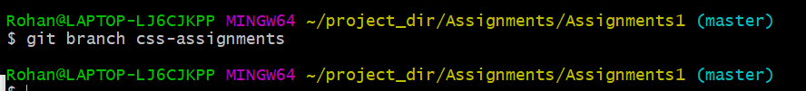

Q2. Switch to ‘css-assignments’ branch.

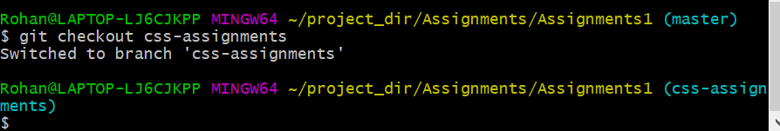

Q3. Copy all CSS assignments inside ‘Assignments’ folder.

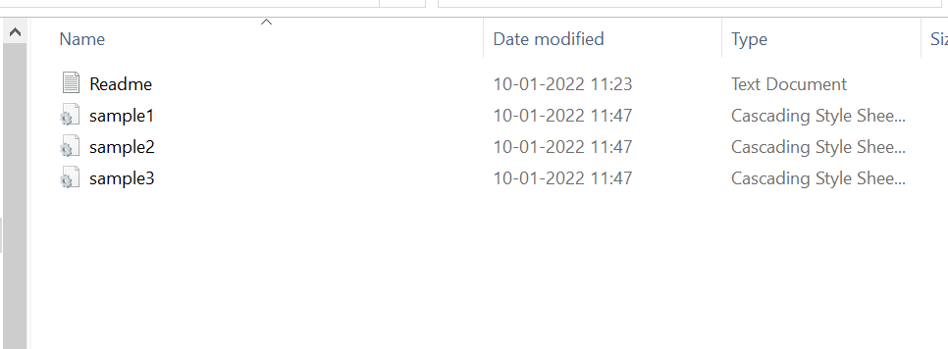

Q4. Commit CSS assignments into ‘css-assignments’ branch.

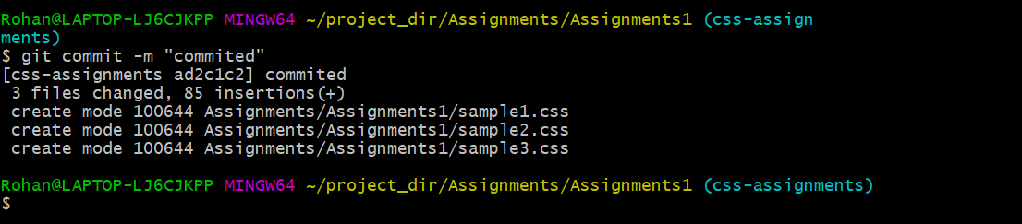

Q5. Make minor changes into README.txt file on line 1 belonging to ‘css-assignments’ branch.

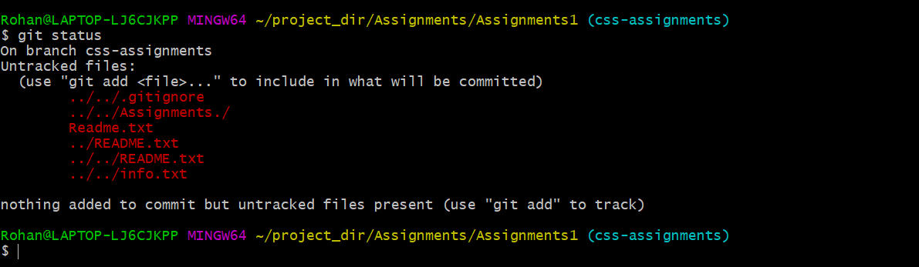

Q6. Commit those changed files.

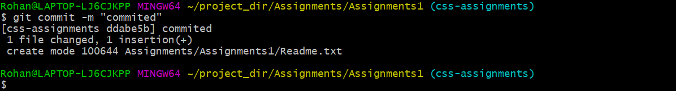

Q7. Switch to master branch.

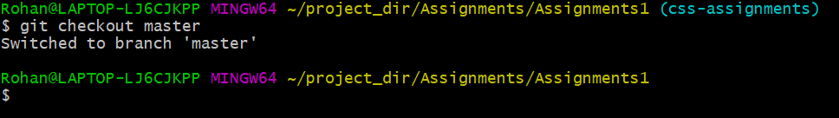

Q8. Make minor changes into README.txt file on line 3 & commit those changes into master.

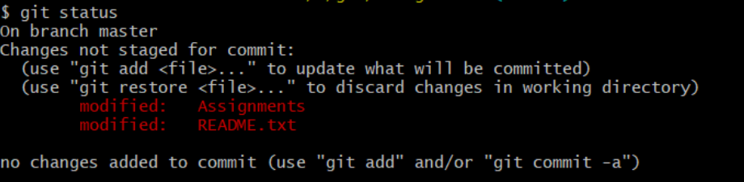



Q9. Again switch to ‘css-assignments’ branch.



Q10. Make minor changes into few files belonging to ‘css-assignments’ branch.



Q11. Commit those changes.

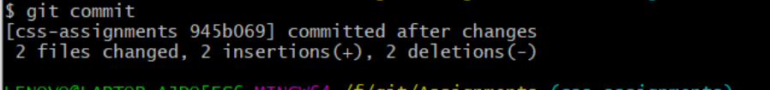

Q12. Switch to master.

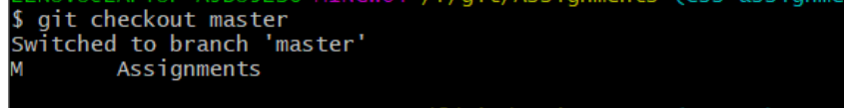

Q13. Merge ‘css-assignments’ branch into master. Confirm all css assignments are shown in master.

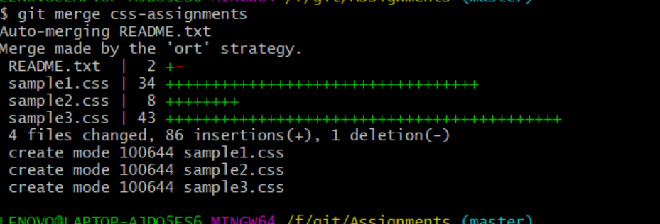

Q14. Finally delete the ‘css-assignments’ branch.

